Group 6

**Client-Side App Rubric** <https://github.com/denisecase/pbl-lifeline-links>

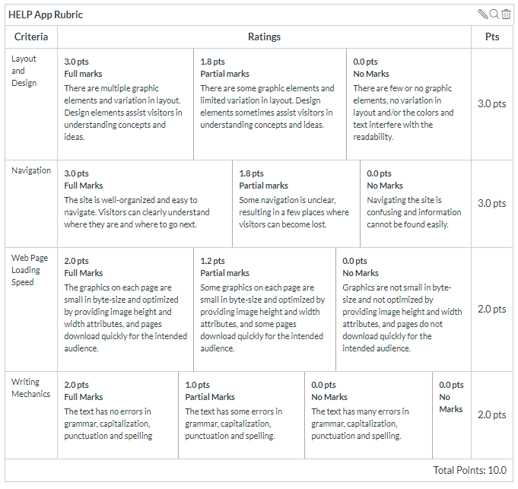

**Team reviewed:**

**Link to the web site:**

https://jeevanreddymure.github.io/Help/

**Layout and Design**

Score: 1.8

Comments:

* **Program**
  + Some of the pop-ups were the generic filler provided by Wordpress.
* **History Page**
  + Should have a larger border width. It’s hard to read with it so close to the edge.
  + It’s a bit odd that it’s the only element not within the first page.
* **Footer**
  + Not present
* **Philips Lifeline link**
  + Nice touch, however see if you can route it to open in a new tab instead of the current one viewers are in
* **Pricing**
  + Can you center the lost equipment fees? It would add a nice contrast and break for viewers.
* **Local Partners**
  + Add a new section for this as it doesn’t have the same content value for where it’s currently placed.

**Navigation**

Score: 0

Comments:

The navigation tags are there, but don’t work once on the History page.

**Loading Speed:**

Score: 3

Comments:

Good, no problems

**Writing Mechanics:**

Score: 1

Comments:

* No errors, but there is missing content.

**General remarks:**

* Nice color choices
* Good for an older audience, though some text could be a bit bigger, especially the body text.

**Review performed by:**

Group 2

**Date and time performed:**

November 5- 12:45 pm